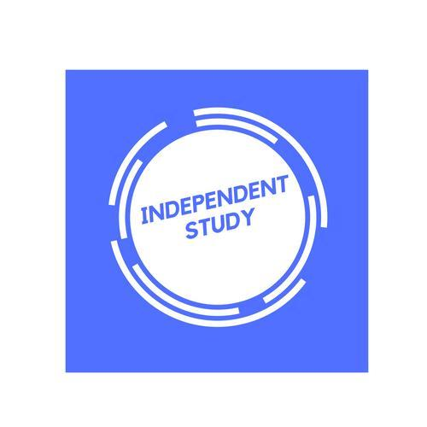 | Independent Learning in  History | 

After each lesson, in addition to completing any work set, a pro-active independent learner would……  - Ensure that lesson notes are completed and filed in the correct section.  - Read through lesson notes to identify any points where you need to add more detail, seek further clarification or ask a question next lesson.  - Mark off completed topics on the specification overview.  - Respond to any feedback on marked work e.g. essays given back that lesson.  - Make a list of the areas for improvement identified in your essays so far, refer to these every time you write an essay.  - If relevant (e.g. below target grade), redraft and resubmit a piece of written work.  - Email the teacher with any questions you have which you cannot find the answer to yourself.  - At the end of a topic, produce a mind map summary of the key points.  - Set quiz questions on a topic to test your understanding, see how many you can answer the next week, the next month.  - Do additional essay questions – as plans or full answers.  - Read the next section of the textbook ahead of the next lesson.  - Read something from the Extra Reading list on the course overview.  - Watch any TV dramas or documentaries relevant to the course. | Effort Grade
Resources to help you study
Resource | Description
Specification/topic checklist | A list of the topics covered in each unit.
Hodder History textbook | Core textbook for Year 12, covers Germany and Italy
Access to History textbook | Core textbook for Protest, Agitation and Reform unit in Year 13.
Pearson textbooks | Additional textbooks written for our specification (green for Year 12, brown for Year 13)
Hodder ‘My Revision Notes’ | Revision guides for the 3 examined topics, include practice questions and model answers.
Past papers, mark schemes, examiner’s reports. | On p-drive, also Pearson website  https://qualifications.pearson.com/en/qualifications/edexcel-a-levels/history-2015.html
Stretch yourself- subscribe to the Modern History Review or Hindsight magazines.

