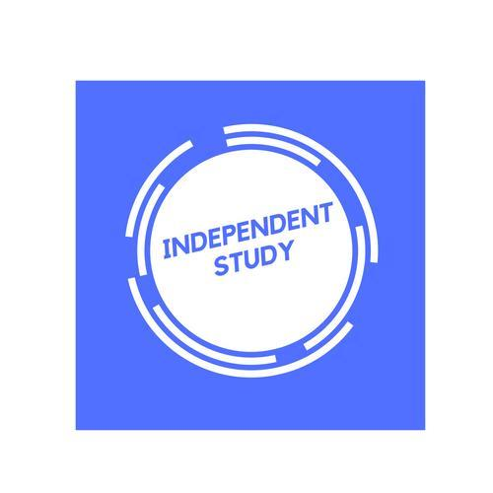 | Independent Learning in    Geography | 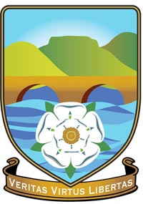

After each lesson, in addition to completing any work set, a pro-active independent learner would……  - Ensure that notes are completed and filed properly in your folder  - Read the relevant textbook pages and annotate lesson notes with additional information and research  - Use the PLC for each enquiry question and identify which areas need looking back over  - Redraft exam questions after feedback has been given  - Use the mark schemes and self-mark exam questions  - Have a copy of the specification and read ahead for the next topic/lesson.  - Listen to podcasts, watch the news, and keep up to date with current affairs. Add these into your notes into the relevant units. | 
Resources to help you study
Time for Geography Really great videos from University Geography Departments
The Guardian Many useful articles and logically ordered–keep an eye on the Environment, Science, Society, Global Development stories in particular.
BBC News An excellent source of up to date articles–explore the key headings such as Science, Business, as well as the UK, World and other stories.
The Coversation.com You will find this really useful to support many of your A Levels. It provides Up to date articles from academics and specialists in the field written in a way that is accessible to all, summarising key points in short but insightful articles.
Costing the Earth There are some great podcasts here to pick from on a wide variety of geographical issues including climate change, carbon, urban greening, deforestation, alternative power, plastics etc.
Royal Geographical Society fantastic set of podcasts to keep A Level studies up-to-date with the latest geographical research –pick out some that interest you and give them a go!
The Documentary podcast From the BBC, these podcasts investigate global development issues and affairs.
The Inquiry BBC podcasts exploring the trends, forces and ideas shaping the world beyond the headlines.
Podcasts from Oxford University Geography Department These online audio resources consist of lectures, seminars and interviews from the School of Geography and the Environment at the University of Oxford.
Talks from the Royal Geographical Society From microplastics to microfinance, the RGS have released over 50 free geographical talks for you to watch and listen to.

INDEPENDENT READING LIST

https://www.rgs.org/ Royal Geographical Society. A host of information including podcasts and lectures.
https://timeforgeography.co.uk/ Time for Geography. Excellent for short video clips, especially for processes and landform in physical geography.
https://geographical.co.uk/ The Geographical Magazine online. The ‘go to’ magazine for all geographers – excellent!
https://vicetv.com Vice TV Channel Topical geographical videos can be found here particularly in relation to ‘identity’ and the ‘environment’.
https://www.journeyman.tv Journeyman Pictures Fantastic Australian Documentaries covering a range of geographical topics
https://www.gapminder.org Gapminder Founded by Hans Rosling – videos and interactive graphs on development and inequality.
https://worldmapper.org Worldmapper Maps with a difference to give a different perspective on geographical themes and issues. Podcasts Geography Ninja –
https://podtail.com/en/podcast/geography-ninja Covering a vast array of topics Ask the Geographer
www.bbc.co.uk/podcasts/worldserviceradio The Documentary Podcast. Longer podcasts which sometimes focus on environmental and developmental issues.
https://www.youtube.com/watch?v=XjG4j7M3f9s The curious geographer – great interviews
